**Capstone Project**

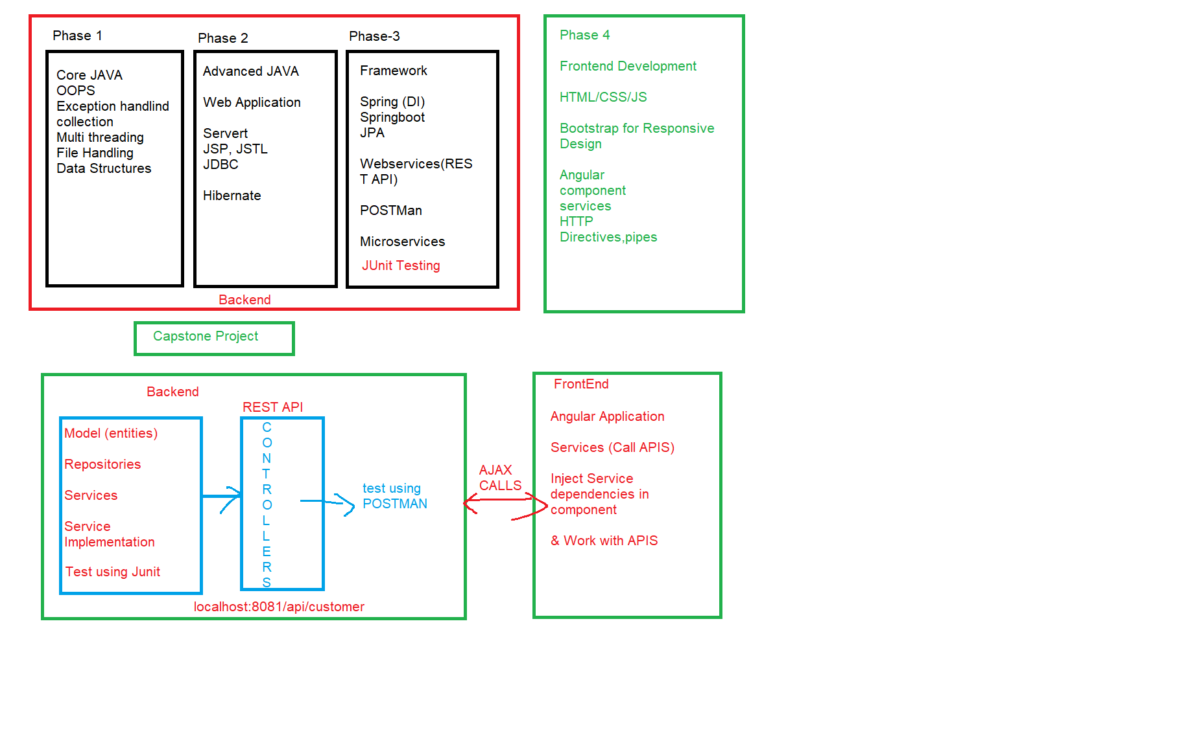

**Project 1: Medicare**

**Create an Online Ordering of Medicine Application.**

**No users: 2**

**Admin User:**

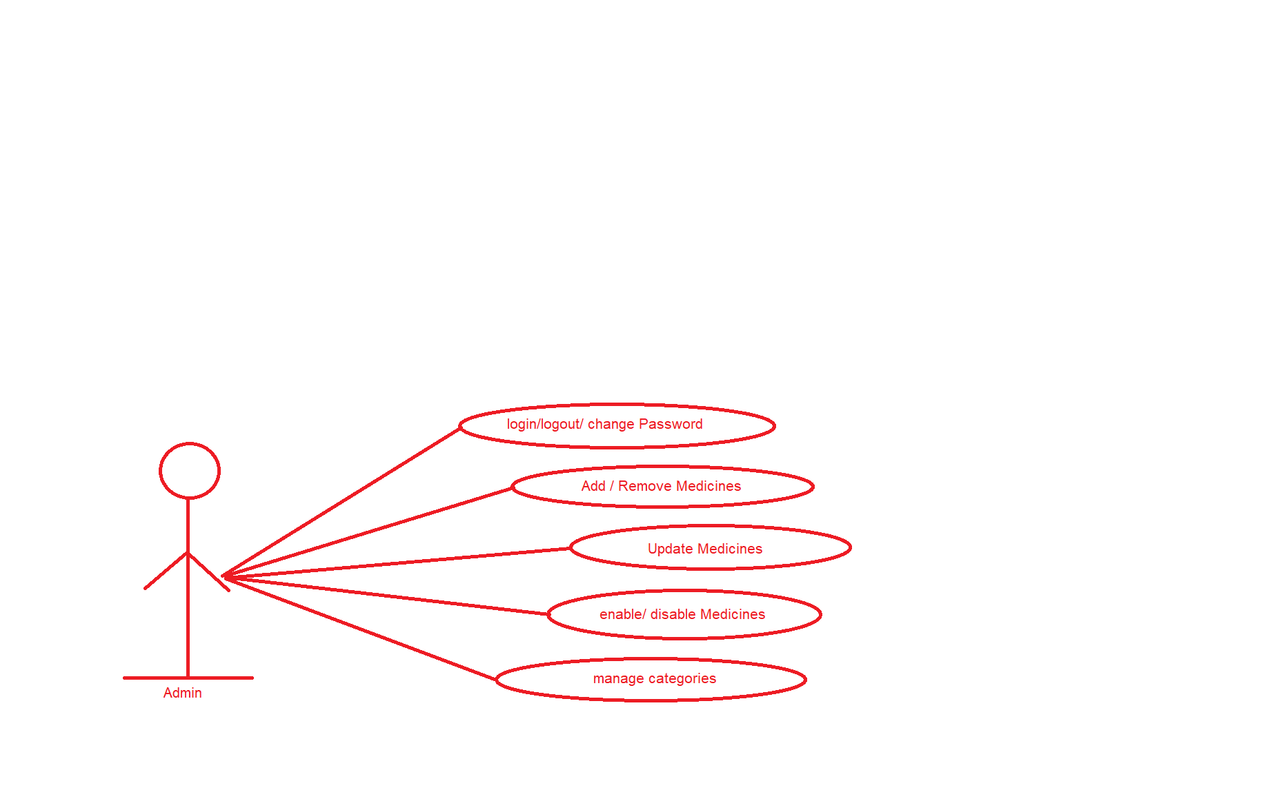

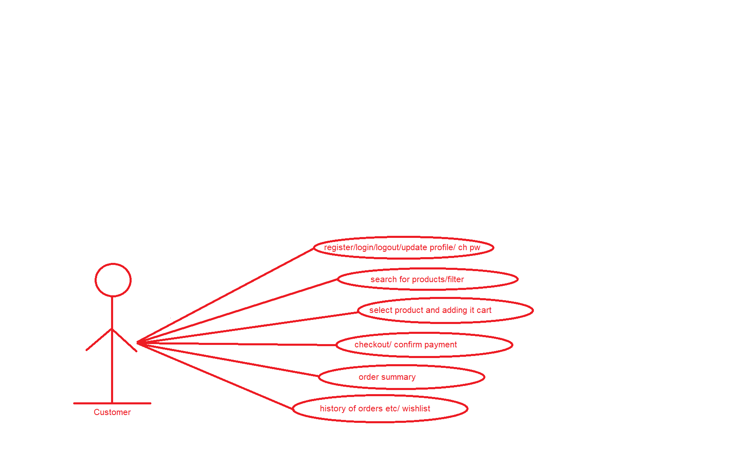

**User Perspective**

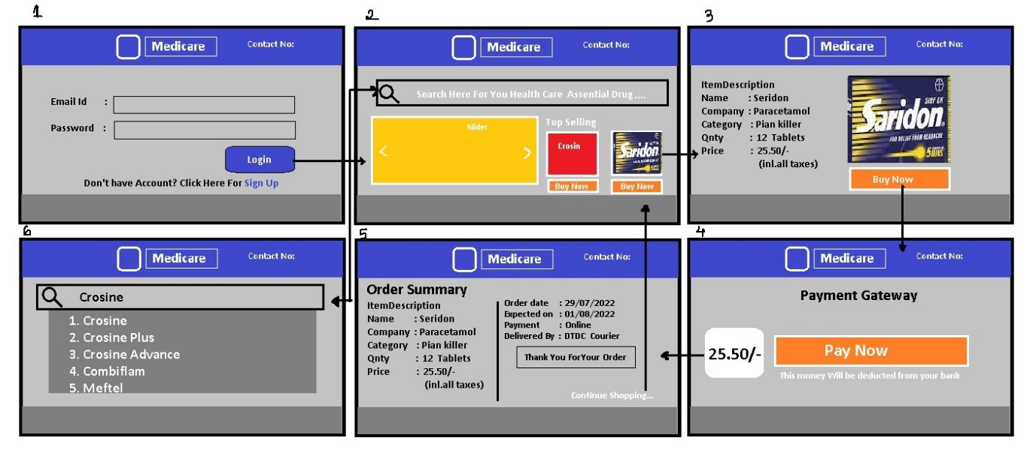

**Admin Perspective**

